Manish.V
2023BCSE07AED598
GENDER EQUALITY SURVEY REPORT

Total Respondents: 20 | Survey Mode: Online (Google Forms) | Date: March 2025
Purpose: Academic Study — College Research Project

Introduction
Gender equality and inclusivity are essential elements of a fair and progressive society. Ensuring that individuals of all gender identities have equal opportunities, safety, and representation is fundamental to both social and academic development.
This survey was conducted to understand people's perceptions of gender equality, discrimination, household responsibilities, workplace challenges, and related social attitudes within academic and social environments. A total of 20 respondents participated in the survey and shared their opinions on 15 key questions. The results provide valuable insights into how young people perceive gender equality today and what improvements may be needed to create a more equitable and inclusive environment.
The survey was distributed online via Google Forms to college students. Respondents were predominantly female (65%), reflecting the focus of the survey on gender equality perceptions, alongside male (20%) and other-gender (15%) respondents to ensure comparative perspectives.

Survey Analysis
The survey responses show that most participants are undergraduate students, while a significant portion are postgraduate students. Most respondents identified as female, which aligns with the focus of the survey on gender empowerment and equality.
When asked whether gender discrimination still exists in society, an overwhelming 80% of respondents said Yes, with 15% selecting Maybe. This indicates a very high level of awareness of the persistence of gender-based discrimination among college students today.
On questions of shared responsibilities, respondents showed strong consensus. Every single respondent agreed that household responsibilities should be shared equally by both genders, and 95% affirmed that education should be equal for all. These findings suggest that egalitarian values are deeply internalised among educated youth.
The workplace emerged as the primary site of perceived gender inequality, cited by 55% of respondents. This was followed by society in general (20%), education (15%), and the home environment (10%). In terms of leadership, 95% of respondents agreed that women should have equal leadership opportunities as men.
On the question of equal pay, 90% of respondents either Strongly Agreed or Agreed that men and women should receive equal pay for the same job. Similarly, 95% supported equal sports access for boys and girls, and 80% agreed that both parents should share equal responsibility in raising children.
When asked about gender in job selection, 85% of respondents stated that gender should never be a factor and that skills should matter more. Finally, 70% of respondents agreed that women face significantly more challenges in the workplace than men, while 25% felt challenges are equal across genders.

Key Findings
From the survey results, several key observations can be identified:
- 80% of respondents confirmed that gender discrimination still exists in society.
- 100% of respondents agreed that household responsibilities should be shared equally by bothgenders.
- 95% believe education should be equal for all genders.
- The workplace was identified as the primary site of gender inequality by 55% of respondents.
- 95% of respondents support equal leadership opportunities for women.
- 90% Strongly Agree or Agree that men and women should receive equal pay for the same job.
- 85% stated gender should never be considered in job selection — skills alone should matter.
- 70% of respondents agreed that women face significantly more workplace challenges than men.
- All respondents rated gender equality as either Important or Very Important for societaldevelopment.

- What is your gender?
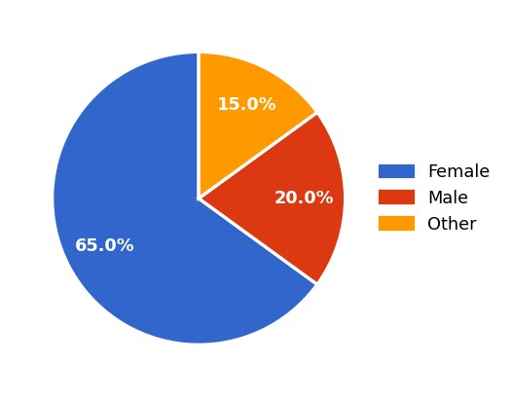
20
responses
- What is your age group?
20 responses
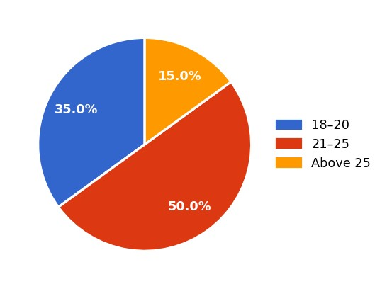
- What is your education level?
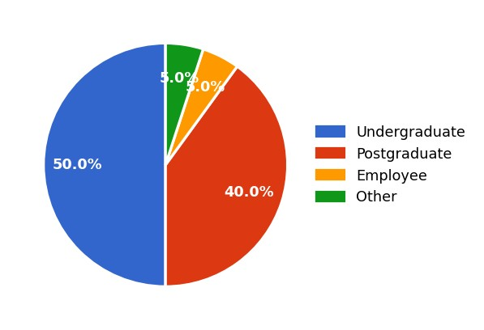
20
responses
- Do you think gender discrimination still exists in society?
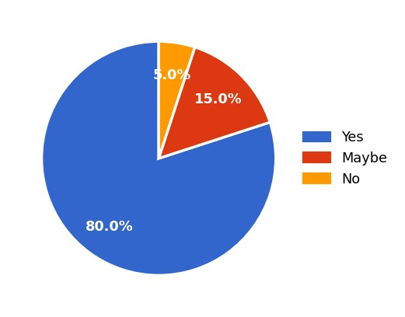
20
responses
- Who should share household responsibilities?
20 responses
100% of all respondents selected Both equally — a unanimous consensus that household responsibilities should be shared regardless of gender.

- Do you believe education should be equal for all genders?
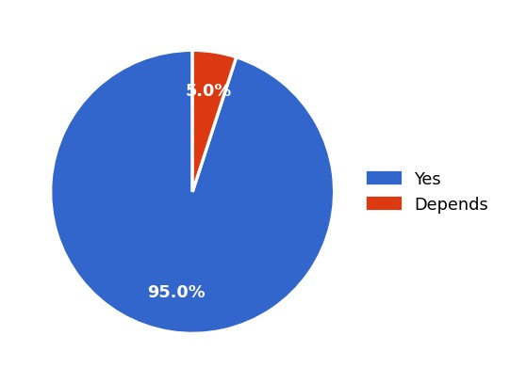
20
responses
- Where do you think gender inequality occurs the most?
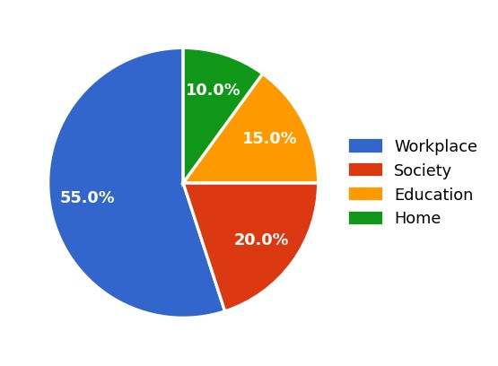
20
responses
- Should women have equal leadership opportunities as men?
20 responses
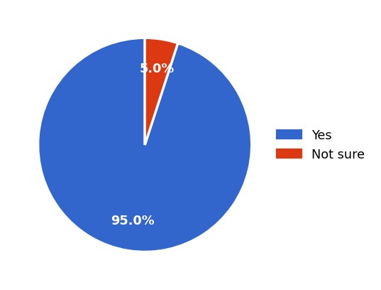
- How important is gender equality for the development of society?
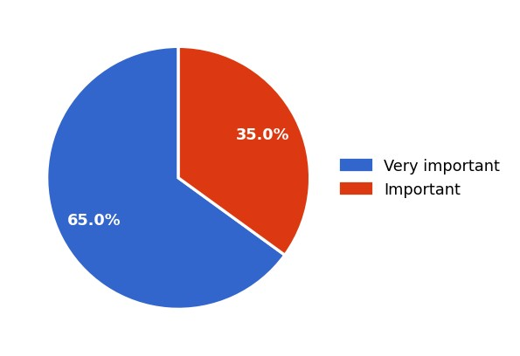
20
responses
- Do you think men and women should receive equal pay for the same job?
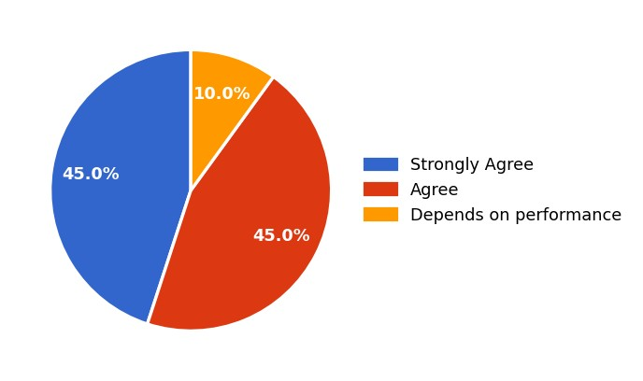
20
responses
- Should boys and girls have access to the same sports activities?
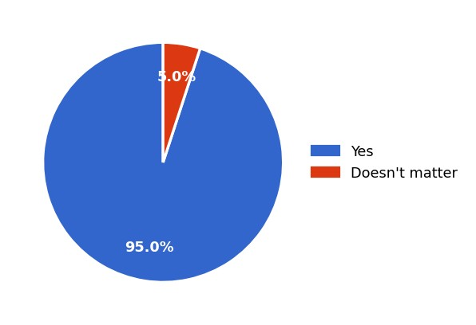
20
responses
- Should both parents share equal responsibility in raising children?
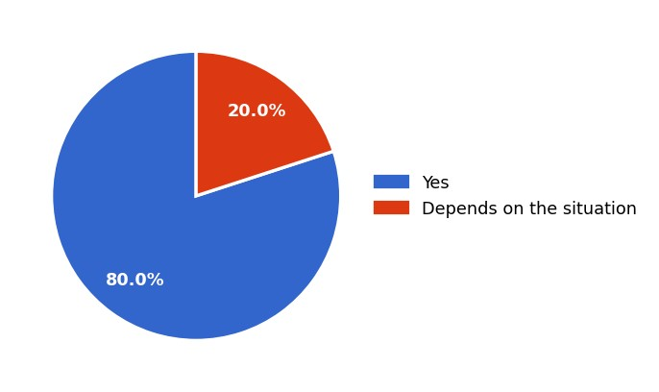
20
responses
- Should gender be considered when selecting a candidate for a job?
20 responses
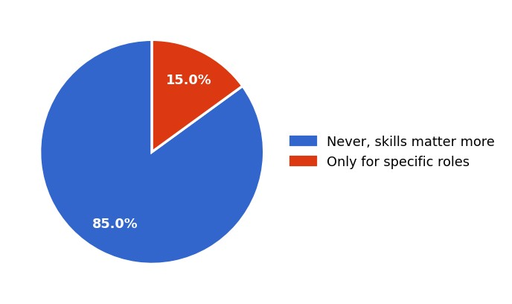
14. Do you think women face more challenges in the workplace than men?
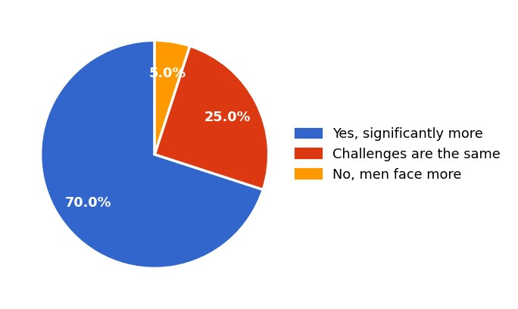
20
responses

Conclusion

The survey results indicate that awareness of and support for gender equality are strongly present among the respondents. The vast majority of participants — all college students — recognise the existence of gender discrimination and express clear support for equal treatment, equal pay, equal education, and equal leadership opportunities across all genders.
Respondents demonstrated particular strength in their views on workplace equality, household responsibility sharing, and merit-based job selection. The workplace was consistently identified as the area most in need of improvement, with 70% agreeing that women face significantly greater professional challenges.
However, the responses also suggest that awareness alone is not sufficient. Cultural and social norms, gender stereotypes rooted in family environments, and a lack of institutional enforcement were identified as the most significant barriers to achieving true equality. Overall, promoting awareness, creating supportive environments, and ensuring equal opportunities at every level of society remain essential to building a more inclusive and equitable future.

